**Serial Port Communications in Linux**

1. SOcket CAT (socat) – Setup for usage similar to com0com in Windows

– Creates bidirectional byte streams and transfers data between them. It can be used to set up virtual ports (like com0com in Windows)

1. From the terminal install using: $ sudo apt install socat
2. See how it works (options) by typing: $ man socat
   1. The option needed to set up a pseudo terminal (PTY)
3. Go to the dev folder to see currently existing devices: $ cd /dev
4. Create two new PTY devices, connect and start data transfer between them using:

$ socat -d -d pty pty

Note: The terminal you use will hang (be active since data transfer in progress). It will tell you which pseudo-terminal (pty) devices are connected together (in the ‘/dev/pts/’ folder)

Example: N PTY is /dev/pts/18 (One side of connection)

N PTY is /dev/pts/19 (Other side of connection)

1. Open another two terminals and send a message from one virtual port to the other
   1. Terminal 1: Start reception: $ cat < /dev/pts/19
   2. Terminal 2: Transmit: $ echo “hello” > /dev/pts/18

Note: The first echo may not register so try twice.

1. When you wish to quite transmitting press ctrl-z in each terminal
2. How to find out which serial ports are available?

When you plug in a USB-Serial adapter if you are using a virtual machine you will see a message as shown in figure 1. Select the option to connect the device to the virtual machine.

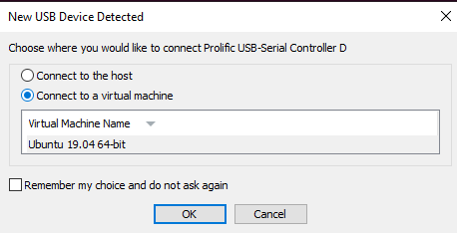

Figure : In a Virtual Machine you should choose to connect the USB-Serial Adapter to the host

Depending on the USB-Serial adapter you use you may need to change the USB settings in VM Ware

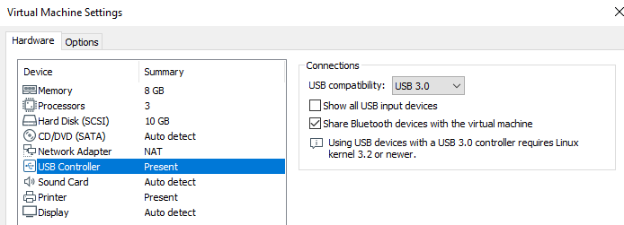

Figure : Set USB compatibility to v 3.0

To view the available serial devices use the command: $ dmesg | grep tty

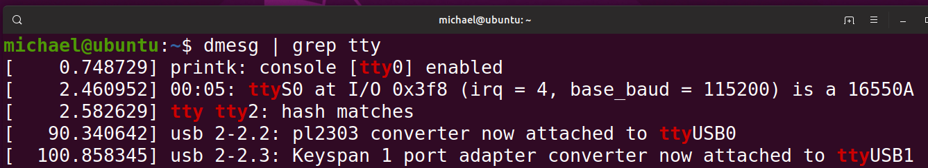

Figure : Typically the device shows up at ttyUSB0 or ttyUSB1 after it is connected

Open another two terminals (if you have 2 USB-Serial devices on the same computer) and send a message from one port (ttyUSB0) to the other (ttyUSB1).

Before you will be allowed to read and write to the device you will have to add your username to the group that has access to the files in the /etc folder. The two groups you will need to be a member of to have access to the files used for serial communications are: ‘tty’ and ‘dialout’

To add yourself to the groups:

$ usermod -a -G tty <yourUsername>

$ usermod -a -G dialout <yourUsername>

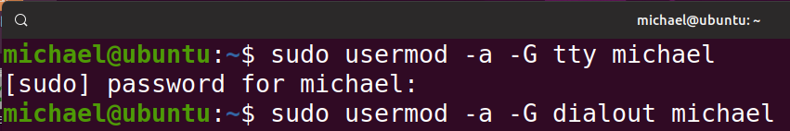

Then **reboot** and log back into Linux.

To make sure you are now a member of the two groups type:

$ groups

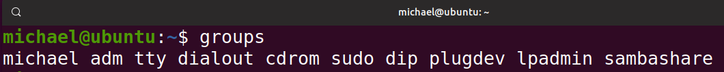

Next you can now access the devices (they are ‘files’ in Linux)

* 1. Terminal 1: Start reception: $ cat < /dev/ttyUSB1
  2. Terminal 2: Transmit: $ echo “hello” > /dev/ttyUSB0

If you have problems communicating, there may be a USB compatibility issue (see above), there may be a driver issue or a settings issue.

You can change the baud rate using the following terminal command. Make sure that both Tx and Rx have the same baud (bit) rate.

$ stty -F /dev/ttyUSB0 <baudrate>

Is there a Program for conveniently changing multiple setting up serial ports in Linux?

Yes, its called minicom. Install via: $ sudo apt-get install minicom

You may wish to play with it to see if you can change settings.

Working Demo

